(Company Profile)

Mission for Resilient Society

Sustainable and Resilient Ideas Pvt. Ltd.
(SRI)

Mahalaxmi Municipality-05, Lalitpur, Nepal
Contact No: +9779851269077, E: sustainable2072@gmail.com, info@ sri.com.np W: www.sri.com.np




Overview
The Sustainable and Resilient Ideas Pvt. Ltd. (SRI) is a professional consulting firm founded in November 2015. It is extensively involved in providing its competent services in the field of research, study, analysis, survey, training and design of renewable energy technologies and infrastructure as well as in the field of business development, socio-economic and environment. The company possess experiences in carrying out these mentioned activities. SRI focuses on following five clusters to build a sustainable and resilient society.
Infrastructure: It is the backbone of development which helps to boost the economic standard of the societies by reducing per unit production cost of product. Increase in infrastructure (private and public infrastructure applying at least basic standard) increases the connectivity, mobility, job opportunities. SRI focuses on developing GESI friendly sustainable and resilient infrastructure, to boost the economic development of the societies and thereby improving the living standard of the people.
Scarce resources, it signifies that a resource has limited availability relative to desired use and thus it is subject to economic analysis. SRI believes in efficient use of resources can produce the same results as used of inefficient excessive resource does. SRI is providing efficient managerial skilled professional to build long lasting infrastructure, using the optimum use of resources.
Disaster: It is an unexpected serious disruption that affects the community or society involving widespread human, material, economy or environment. SRI focuses in strengthening the establishment of resilience and sustainable infrastructure to cope up with climate change and natural disasters. SRI joins the hand with the community and society for building safe and affordable infrastructure, improving disaster resistance, significantly reducing the economic losses relative to climate change and natural disaster.
Time to think resilient aspects: Repetitively building infrastructure, accelerates per unit cost and wastage of resources that reduces economic growth of the societies. SRI provides every effort on building and upgrading infrastructures that could sustain the impact of disasters, enhancing quality, reliability and resilience of infrastructure and reduce the wastage of resources.
Innovative ideas, project, pilot activity: SRI promotes sustained, creative, innovative, resilient ideas and projects to access for the good cause of the surroundings. Innovation in sustainable work is key to improving competitiveness, increasing growth, and creating jobs. SRI emphasize in innovation, creation and pilot project that unfold the hidden opportunities and economic growth for the societies.


Capable Institutions

Capable
Human Resource

Resilient Infrasturcutre

Resilient Economy

Sustainable
Development

3

Specific areas of works
SRI specific area of activities are:
- Evaluation of Programmes/Projects related to different sectors;
- Baseline and Project document development, gap analysis related to development programmes and projects;
- Preparation of guidelines for monitoring and quality assurance for organizations;
- Enterprise development and Productive End-Use (PEU) of energy;
- Climate change adaptation and mitigation;
- Energy planning of commercial building, institutional establishment and municipalities;
- Initial Environmental Evaluation (IEE), social and environmental impact assessment;
- Monitoring of development projects and programs;
- Detail feasibility study of developmental projects and programs from the prospective of resilient and sustainability;
- Execution of training, workshop and conference on enterprise creation and development, entrepreneurship development, poverty reduction, GESI, climate change mitigation, alternative energy promotion, and wildlife;
- Design of innovative ideas, concept and programs in rural/urban development, rural financing, rural transport, clean energy based mobility, disaster management, and renewable engineering, rural transport.
Further, SRI having another strong pillar about the local governance, livelihoods, poverty alleviation, economic empowerment, GESI, and programme management which provides strategic advices, lead national and an expat team to serve to the poor and vulnerable communities to improve their livelihoods, providing good governance at the sub-national level in Nepal and developing countries. Managing, leading the team for designing, appraisal and monitoring and multi sector proposal on poverty alleviation.
Vision
SRI becomes the centre for providing unique solutions at International and National levels working together with Government organizations, International organizations, Private sectors, and Development partners to achieve a sustainable and resilient society.

4
Mission
SRI is committed to join hands with the government, national and international organizations, private sectors, and development partners for the creation of prosperous resilient societies though sustainable development that is powered by clean, affordable, and sustainable energy. In order to achieve its vision and mission, SRI has following sets of strategies:
- Accelerate the development and adoption of sustainable and resilient technologies.
- Increase the involvement in climate change and energy based research and projects.
- Enable a high-performing, results-driven culture through effective management approaches and processes.
- Increase the involvement in the GESI friendly projects and activities.
- Extensive promotion in research and development related to resilient and sustainable infrastructure.
Support to SDGs Goals

The Government of Nepal (GoN) has reset Sustainable Development Goals (SDGs) with its target, and expects to become a vibrant middle income country by 2030. SDGs are interlinked, indivisible, and ambitious posing major implementation challenges in a low-income country like Nepal, which has resource constrained. However, Nepal was probably one of the first countries to produce a SDGs baseline study in 2015 for economic, social and environment development, before the formal adoption of the SDGs. SRI is continually working with the government authorities at national, regional, and community levels to achieve the set SDG targets: Basic mark of civilization, Human capacity and ability utilization, Human aspiration, Sustaining progress and development, Reducing risks of future, and Means of implementation and global collaboration.

5
Our Team
Management Team

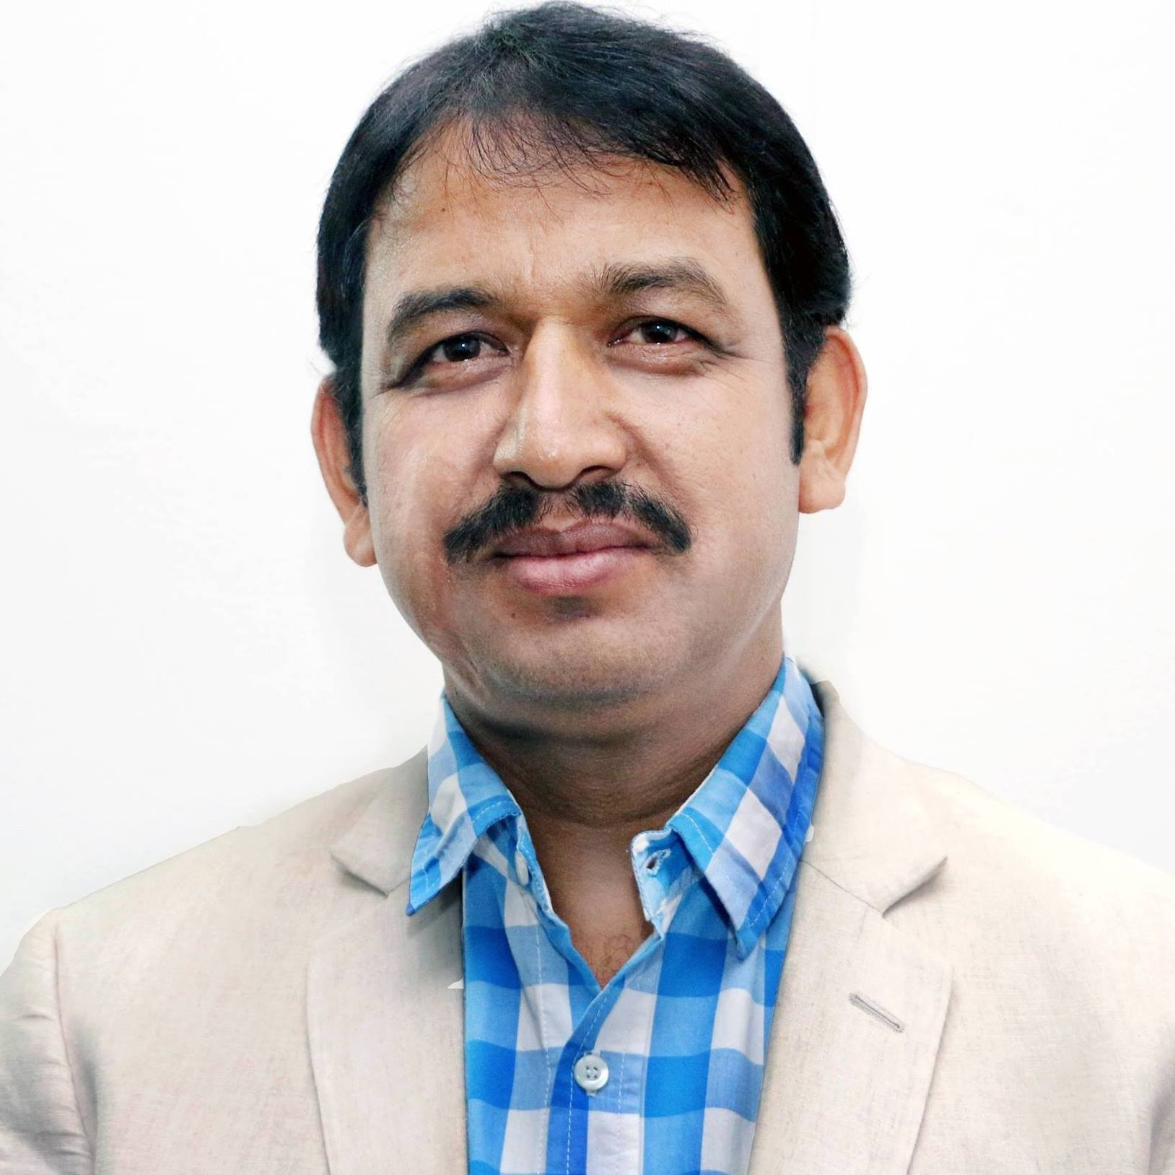 | 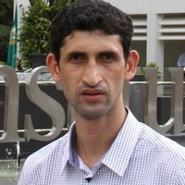 | 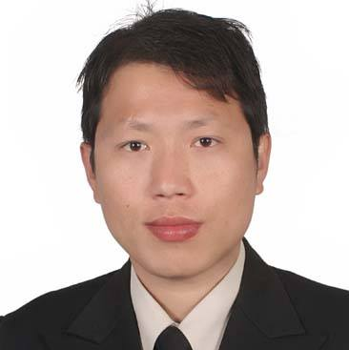
Nahakul K.C  Chief Executive Officer | Bikash Adhikari  Managing Director | Pratap Jung Rai  Technical and R&D Director
Advisors

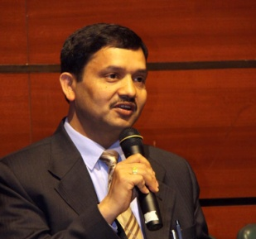 | 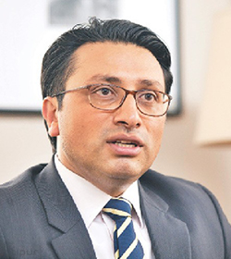 | 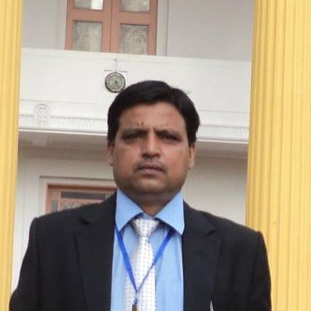 | 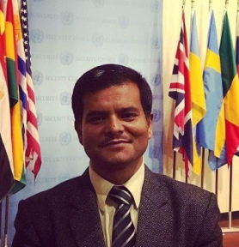 | 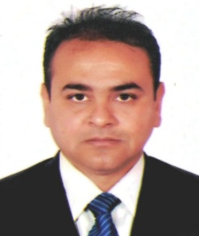
Prof. Dr. Govind Raj Pokharel | Dr. Swarnim Wagle | Prof. Dr. Laxman Poudel | Assoc. Prof. Arbind K.Mishra | Dr. Nawraj Bhattarai

Experts

Nahakul K.C.: Senior Local Governance, Poverty, Program Management Expert
Key Strengths:
Programme Management, Sub-national Governance, Climate Change and Monitoring.
Professional Experience:
Mr. K. C. has more than 15 years of professional experience in senior managerial positions with the partnership of government, multi and bilateral donor agencies, civil society and private sector on resource mobilization programme management policy/strategy.
Academic Record:
Master of Public Administration (MPA), IGNOU-Delhi, India; Master of Sociology; Community Development (MCD), College of Social Work and Community Development, University of the Philippines, Dileman Quezon City, Philippines; Bachelor of Arts (BA) in Economics and Political Science; Mahendra Multiple Campus Dang, Tribhuwan University, Nepal; Summer Scholl Graduate on “Measuring Multi-Dimensional Poverty Analysis” from OXFORD University UK.
6

Uttam Jha: Senior Energy Business Expert
Key Strengths:
Program Management, Organizational and capacity development, Training and Workshop management, and Monitoring & Evaluation in renewable energy and climate change sector.
Professional Experience:
Mr. Jha has more than 20 years of working experience in senior managerial and advisory level in government and international organizations in which more than 10 years of professional experiences in renewable energy and climate change sector in national and international organizations.
Academic Record:
Masters of Geography, Tibhuvan University, Nepal; EMBA, Hope College, PU; Bachelor of Geography and Economics, Tibhuvan University, Nepal; Management Auditor Course under ISO 9001:2000, Australia-New Zealand Joint Accreditation System.
Barun Kanta Adhikari: Senior Monitoring and Evaluation Expert
Key Strengths:
Result based monitoring and evaluation of development programs/ projects with extensive experience on local governance, renewable energy, water, sanitation and hygiene (WASH), and community development.

Professional Experience:
Mr. Adhikari has worked for more than 15 years in the field of monitoring, evaluation and planning in I/NGOs and government bodies of Nepal related to the development field.
Academic Record:
Master’s in Sociology and Graduation in Civil Engineering.
Jagadish Kumar Khoju: Senior Project Management Expert
Key Strengths:
Renewable Energy Programs/projects planning, co-ordination, implementation and technical expertise
Professional Experience:
Mr. Khoju has more than 20 years of experiences in advising, managing and implementing renewable energy programs and projects by remaining in several senior positions in International and National organizations of Nepal.
Academic Record:
7
MSc in Project Management, Northumbria University, Newcastle upon Tyne, the United Kingdom; M.Sc in Engineering in Mechanical Engineering, Zaparozhye State Technical University, Zaparozhye, Ukraine (the former USSR); Proficiency Certificate Level in Engineering (Mechanical), Institute of Engineering, Thapathali Campus, Tribhuvan University, Nepal
Pankaj Kumar: Senior Capacity Development Expert- Renewable Energy
Key Strengths:
Capacity development, management, planning, monitoring and evaluation related to renewable energy sector.
Professional Experience:
Mr. Kumar has more than 17 years of field level experience with national and bilateral partner agencies in the field of renewable energy, institutional solar, capacity development expert, Team Leader, Liaison, project administration and management, budget and planning, monitoring and evaluation, finanancial management, project coordination, surveyor, logistics and technical management of solar PV (ISPS, grinding and water pumping), hydropower development and academic sector of Nepal.
Academic Record:
Masters in Rural Development, Central Campus, Tribhuvan University, Nepal; Bachelor of Engineering in Electrical, Regional Engineering College (REC/NIT), Durgapur, India; 76th UNEP/UNESCO/BMU Fellowship Award "Renewable Energy Sources and Energy Efficiency", 2018, Germany.
Bibhuti Bista: Senior Project Development, Monitoring & Evaluation, Planning Expert
Key Strengths:
Monitoring and Evaluation, project planning and implementation, research related to development sector.
Professional Experience:
Mr. Bista has more than 13 years of experience working with non – profit making organizations, International Non-Governmental Organizations and as independent researcher and consultant. Mr. Bista has worked as full-time staff in National and International organization, served as Evaluation and Research Consultant to International Non-Governmental Organizations and Non-Governmental Organizations in Nepal and abroad (Cambodia).
Academic Record:
MA in Social Sciences (Sociology), Sagarmatha Multiple College, Nepal; BSc (Hons.) Environmental Science, Kathmandu University, Nepal.
Subash Chandra Baral: Senior Hydro Power Expert
Key Strengths:
8
Design and management of Hydro Power projects.
Professional Experience:
Mr. Baral has more than 15 years of experiences in designing and management of hydropower projects of Nepal like (Khani Khola-1 Hydropower Project – 40MW), Lower Hewa Khola Hydropower Project (9.5 MW, upgraded to 22MW) located at Panchthar District.
Academic Record:
Master of Science in Engineering in Water Engineering, Institute of Engineering, Pulchowk, Nepal; Bachelor of Engineering in Civil Engineering, Institute of Engineering, Pulchowk, Nepal.
Bikash Adhikari: Senior Renewable Energy and Climate Change Expert
Key Strengths:
Management, project development and implementation,research, planning, policy related to development sector specially in renewable energy and climate change.
Professional Experience:
Mr. Adhikari has more than 7 years of experiences in renewable energy and climate change sector remaining in various positions. Management experiences of organization and projects related to energy, climate change and other sustainable development sector.
Academic Record:
Master of Engineering in Energy (specialization: energy policy, planning, and economics), Asian Institute of Technology (AIT), Thailand; Bachelor of Engineering in Mechanical, Quaide Awam University of Engineering, Science, and Technology, Pakistan.
Pratap Jung Rai: Senior Renewable Energy, Energy Policy and Climate Change Expert
Key Strengths:
Planning, Renewable Energy Policy, Climate Change, R&D, and Project Implementation.
Professional Experience:
Mr. Rai has more than 6 years of work experience in Renewable Energy (RE), Climate Change, Water Supply, Education, and Research & Development Sector in National and International Arena, supported by the International Development Partners and Nepal Government. Highly adept at analysing, modelling, simulation and designing of water supply, waste treatment, biomass, biogas, solar and large/mini/micro hydro power.
Academic Record:
Master of Science in Engineering in Energy and Environmental Technology (Specialized in Energy Policy and Economics, Hydropower and Biogas Modelling and Simulation), University College of Southeast Norway (USN), Porsgrunn, Norway; Bachelor of Engineering in Industrial Engineering, Thapathali Campus, Institute of Engineering (IOE), Tribhuvan University (TU), Thapathali, Nepal; Intermediate in Engineering in Refrigeration and Air Conditioning Engineering, Purwanchal Campus, Institute of Engineering (IOE), Tribhuvan University (TU), Dharan, Nepal.
9
Nanda Kumar Ojha: Senior Biomass Energy Expert
Key Strengths:
Designing, planning and implementation of projects.
Professional Experience:
Mr. Ojha has more than 7 years of experiences in biomass energy in planning, and implementation by remaining in several positions and working in government body of Nepal (Alternative Energy Promotion Centre).
Academic Record:
Master in Sustainable Development, Kathmandu University, Nepal; Bachelor in Agricultural Engineering, Purwanchal Campus, Institute of Engineering, Dharan, Tribhuvan University, Nepal.
Trojan Ram Shrestha: Senior Environmental Expert
Key Strengths:
Environment and Climate Change research and implementation of related projects.
Professional Experience:
Mr. Shrestha has more than 7 years of extensive involvement in environment and climate change sector. Involvement in multiple discussion for accreditation for Adaptation fund (CCMD) and Green Climate fund (MOF) as well as in Environment Management Framework Guideline Orientation, Trainings and Workshops.
Academic Record:
Master of Science in Engineering in Environmental Engineering, Asian Istitute of Technology (AIT), Thailand; B.Sc in Environment Science, Kathmandu University, Nepal.
Deepak Parajuli: Industrial Expert
Key Strengths:
Research
Professional Experience:
Mr. Parajuli has more than 3 years of experiences by remaining as assistant professor in Nepal Engineering College, Bhaktapur, Nepal and few years of experiences in industries.
Academic Record:
Master of Engineering in Industrial and Manufacturing Engineering, Asian Institute of Technology (AIT), Thailand; Bachelor of Engineering in Mechanical, Meenakshi Academy of Higher Education and Research, Chennai, India
10
Sajan Jung Pandey: Water Resource Expert
Key Strengths:
Water resource expert
Professional Experience:
Mr. Pandey has more than 3 years of experiences in hydro power by remaining as water resource expert and site engineer.
Academic Record:
Master of Engineering in Water Engineering and Management, Asian Institute of Technology (AIT), Thailand; Bachelor of Technology (B.Tech.) Civil Engineering, National Institute of Technology, Warangal – Warangal, Telangana, India.
Deepa Neupane: Environment Expert
Key Strengths:
Research and project development, implementation, and modelling related to Environment sector, Outreach handling and communication.
Professional Experience:
Ms. Neupane has more than 2 years of experiences as remaining project engineer- environmental, and research related activities of climate change sector.
Academic Record:
Bachelor of Technology in Environmental Engineering, Kathmandu University, Nepal
Biplav Pokhrel: Business Development Expert
Key Strengths:
Administration and finance along with program/ project planning and implementation
Professional Experience:
Mr. Pokrel has more than 7 years of experience as a development professional working in the area of administrative, finance, social and local development; and has sound experiences in program planning, management, and monitoring.
Academic Record:
Master in Business Studies, Nepal Commerce Campus, Kathmandu, Nepal; Master in Sociology (ongoing), Ratnarajya Campus, Kathmandu, Nepal; Bachelor in Business Studies, Intensive International College, Kathmandu, Nepal.
Poonam Rai: Business Development and Finance Expert
Key Strengths:
Administration and finance management along with project planning, implementation and execution
11
Professional Experience:
Mrs. has more than 6 years of experience as a development professional in the area of Administration, Finance, Social, Hotel Operation and Local Development sectors, and possesses excellence in program planning, management and monitoring and prominent quality of interpersonal skill, team building and facilitation.
Academic Record:
Bachelor of Business Studies in Management, Einstein Academy, Thasikhel, Mahalaxmi Chowk, Ring Road, Ward No. 14, Lalitpur, Nepal
Kishwor Karki: Field Engineer
Key Strengths:
Trainer for micro-hydro technologies related to installations, operations and maintenance; survey of micro hydro; installations of solar technologies; monitoring of renewable energy technologies at field level.
Professional Experience:
More than 4 years of field level experiences in survery of micro hydro technologies, monitoring of renewable energy technologies, as a trainer for micro hydro installations, operations, and maintenance.
Academic Record:
Bachelor in Electrical Engineering, Kathmandu Engineering College, Tribhuvan University, Nepal
Ramesh Upadhya: Marketing Expert
Key Strengths:
Marketing
Professional Experience:
Mr. Upadhya has experience in marketing in private sector and development worker as volunteer in non governmental organizations and institutions.
Academic Record:
Master in Anthropology, Ratna Rajya Laxmi campus, Tribhuvan University, Nepal.
Padam M.C.: Enumerator
Key Strengths:
Marketing and field data collection
Professional Experience:
Mr.Padam has experiences in marketing, data collections, as office assistant in several organizations of Nepal.
Academic Record:
12
Bachelor degree (ongoing), Gramin Adarsha Multiple Campus, Nepal
Sunil Acharaya: Enumerator
Key Strengths:
Maintenance of micro hydro, and data collection, monitoring at the field level of renewable energy
Professional Experience:
Mr. Acharya has more than 10 years of experiences at field level in renewable energy especially in micro-hydro. Have several years of experiences in data collections, monitoring at the field level of renewable energy technologies in Nepal.
Academic Record:
Bachelor Degree (ongoing) in political science, Swargadwari Campus, Pyuthan, Nepal; I.A. (political science), Swargadwari Campus, Pyuthan, Nepal
12
13

